

AWS Secret Manager –
AWS Secrets Manager is a secure locker where you can store passwords, database credentials, and API keys instead of keeping them in your application code

Why Do We Use AWS Secrets Manager ?
Without Secrets Manager –
Application
│
Hardcoded Passwords/API Keys
│
Security Risk
Problems:
- Secrets stored in source code
- Difficult to update passwords
- High risk of credential leakage
- Manual secret rotation

With Secrets Manager
Application
│
AWS Secrets Manager
│
Securely Retrieves Secret

Advantages –
- Secrets stored securely
- Automatic password rotation
- Centralized secret management
- Improved security
- Easy access through APIs

How AWS Secrets Manager Works –
Application
│
Requests Secret
│
AWS Secrets Manager
│
Decrypts Using AWS KMS
│
Returns Secret

- Store the secret in Secrets Manager
- Secrets Manager encrypts it using AWS KMS
- Application requests the secret
- Secrets Manager decrypts it
- Application receives the secret securely

Types of Secrets Stored –

1. Database Credentials - Username & Password
2. SSH Keys - Private Keys
3. Application Credentials - Third-party service credentials

AWS Services That Integrate with Secrets Manager –
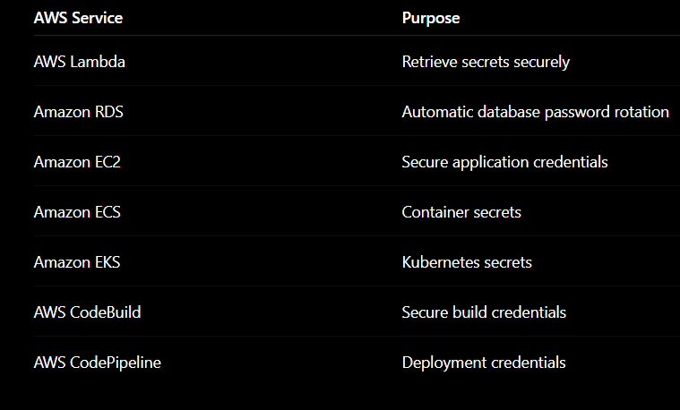
Limitations –
- Charges apply per secret and API requests
- Intended only for sensitive information
- Applications must be updated to retrieve secrets programmatically
- Automatic rotation requires supported services or custom rotation logic

